**Flyback Converter**

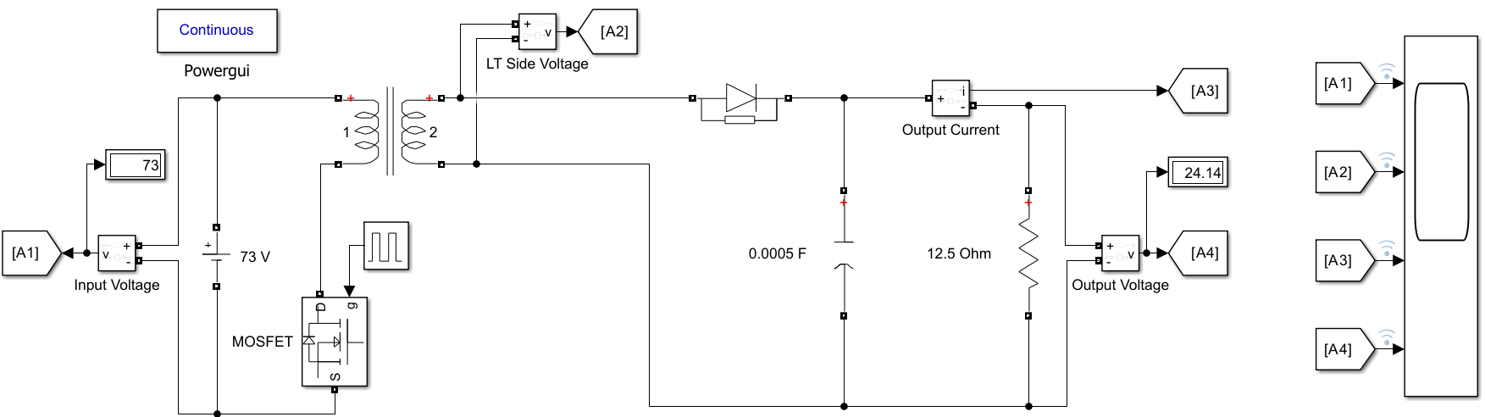

**Fig. Block Diagram of Flyback Converter**

**Flyback Converter**



**Fig. Characteristics of Flyback Converter**

**Forward Converter**

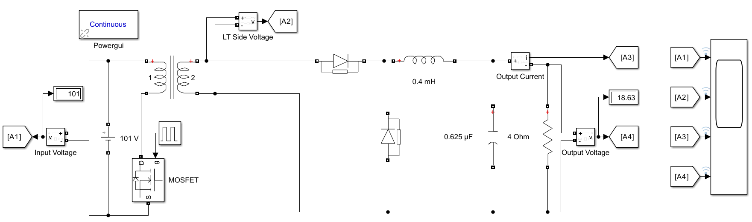

**Fig. Block Diagram of Forward Converter**

**Forward Converter**



**Fig. Characteristics of Forward Converter**